CareLink: An AI-Driven Integrated Healthcare-HR Platform for Coordinated Management of Learning Disorders and Workplace Support

Abstract—This electronic document is a “live” template and already defines the components of your paper [title, text, heads, etc.] in its style sheet. *CRITICAL: Do Not Use Symbols, Special Characters, Footnotes, or Math in Paper Title or Abstract. (Abstract)
Keywords—component, formatting, style, styling, insert (key words)

Introduction
Learning disorders such as dyslexia and dyscalculia are common neurodevelopmental conditions that can significantly affect reading, numeracy, and higher-order work performance across the lifespan [1]. In adulthood, these conditions often translate into reduced productivity, increased stress, and a heightened risk of workplace exclusion if appropriate accommodations and support are not provided [2] [3]. While AI-enabled tools, digital platforms, and smart healthcare infrastructures are increasingly used to optimize diagnosis, monitoring, and occupational health, their potential for coordinated management of learning disorders across healthcare and HR has not yet been fully realized [4] [5].

Background and Problem Domain
Contemporary healthcare systems increasingly rely on electronic health records and AI-based decision support, yet data remain fragmented across institutions, and strict privacy, security, and regulatory requirements limit seamless sharing of sensitive health information [1] [4] [6]. At the same time, HR systems in healthcare and other sectors are beginning to deploy AI-driven analytics for scheduling, burnout detection, and equitable workforce management, raising their own ethical, privacy, and transparency challenges [2] [3]. These two ecosystems—clinical care and HR—typically operate as separate silos, with little real-time integration of diagnostic findings, functional assessments, and workplace accommodations. As a result, employees with learning disorders often face long delays between assessment and the implementation of tailored support, inconsistent communication, and limited feedback loops to refine interventions over time.
Research on smart and federated healthcare emphasizes that integrated, AI-enabled platforms can enable continuous monitoring, predictive analytics, and collaborative decision-making while preserving privacy and regulatory compliance [7]. Similarly, studies on workplace AI and occupational health highlight the value of human–AI collaboration, real-time monitoring, and ethical frameworks to improve safety, equity, and well-being [2] [3] [8]. However, there is a lack of socio-technical systems that deliberately bridge healthcare and HR processes for neurodivergent populations, combining clinical decision support, privacy-preserving data sharing, and workplace planning in a coordinated manner.

Research Gap and Justification
Existing approaches to supporting adults with learning disorders typically rely on static clinical reports and manual HR processes that do not support continuous adjustment of accommodations or systematic monitoring of outcomes. Current AI applications in healthcare focus mainly on diagnostics and predictive analytics within clinical domains; they rarely extend to structured collaboration with HR processes or to longitudinal tracking of workplace impact [1] [7] [9]. On the other hand, emerging AI-driven HR systems concentrate on burnout, turnover, and equity at a workforce level but seldom integrate granular clinical insights from neurodevelopmental assessments [2] [3] [10].

Across both domains, robust privacy and security safeguards are essential. Federated learning and related privacy-preserving AI techniques enable collaborative model training across distributed institutions without centralizing raw data, using mechanisms such as secure aggregation, differential privacy, and cryptographic computation to comply with HIPAA, GDPR and similar regulations [1] [7]. Yet, even in federated settings, model updates can leak information, and issues such as data heterogeneity, fairness, and adversarial attacks require layered defenses and strong governance [4].

Within mental health and neurodivergence management, integrated AI platforms that couple decision support with secure data governance and human oversight are emerging but remain rare and are typically limited to clinical workflows rather than cross-domain HR integration [11]. Narrative and systematic reviews repeatedly call for human-in-the-loop AI, transparency, and ethical safeguards to maintain clinician and worker trust, particularly in high-risk, data-intensive applications [1] [2] [11]. Collectively, these findings reveal a clear gap: there is no comprehensive, privacy-preserving, AI-enabled platform designed to synchronize clinical assessment of learning disorders with workplace accommodations, under explicit human governance and across multiple stakeholder roles.

Research Aim
The aim of this research is to design, develop, and evaluate CareLink, an AI-enabled integrated healthcare–HR platform that facilitates coordinated management of learning disorders by synchronizing clinical assessments with workplace accommodations, enforcing privacy and security requirements, and enhancing intervention adherence and employee outcomes.

Research Objectives
- To analyze current healthcare and HR workflows for managing learning disorders.
- To design a microservices-based platform for real-time, consent-based data sharing.
- To develop AI models for early screening and severity classification, with clinician validation.
- To implement role-based access control and granular consent aligned with HIPAA/GDPR.
- To evaluate effects on time-to-support, adherence, and alignment of clinical/HR decisions.
- To assess user experience for employees, clinicians, and HR, and refine interfaces.

Research Questions
- What are the main challenges and inefficiencies in current clinical and HR processes for learning disorders?
- How can AI-based screening and decision support be integrated ethically and in line with regulation?
- Which architectural and technical approaches best enable secure, seamless healthcare–HR data sharing?
- How does human-in-the-loop oversight affect accuracy and acceptance of AI recommendations?
- To what extent can an integrated platform reduce delays, improve retention, and increase adherence?
- What interface and design features are needed to support different user roles effectively?

Literature Review
This section reviews prior work on AI-driven decision support in healthcare and mental health, data‑sharing architectures, and AI‑augmented human resources management (HRM), to position an integrated healthcare–HR platform for learning disorders within existing research.

AI and Machine Learning in Healthcare and Mental Health
AI is now widely applied across healthcare in diagnostics, predictive medicine, workflow optimization, and clinical decision‑making [12] [13]. Systematic reviews show that machine learning, especially neural networks, support vector machines, and random forests, dominate applications such as outcome prediction and prognosis, with imaging and electronic health records (EHRs) as primary data sources [12] [13].
In mental health specifically, AI‑based clinical decision support systems (CDSS) are emerging but remain under‑studied compared to somatic medicine [16] [11]. Integrative reviews on AI/ML decision support in mental health report small numbers of primary studies and highlight a dominant theme of trust and confidence among clinicians, limited real‑world deployment, and concerns about transparency and user acceptance [16] [11] [17]. Scoping reviews of AI‑enabled mental health tools (e.g., chatbots, NLP systems, LLM‑based agents) show applications across screening, therapeutic support, monitoring, and prevention, often improving access, engagement, and symptom tracking but rarely replacing human care [17].

Overall, the literature supports AI’s potential to enhance diagnosis, triage, and monitoring but stresses the need for rigorous validation, external generalizability, and integration into routine workflows [13] [14] [18].

Human Factors, Trust, and User‑Centered Design
Human factors research emphasizes that many AI systems are developed with limited attention to ecological validity and clinician cognition, leading to usability and workflow problems [19]. Mapping reviews indicate that most health‑AI studies focus on user perception, usability, workload, and trust, but few compare AI tools directly against clinical standards or embed them in real work systems [8].
In mental health, clinicians’ trust, system transparency, and human‑in‑the‑loop oversight are repeatedly identified as preconditions for adoption [16] [11]. Multi‑stakeholder reviews of attitudes toward healthcare AI show generally positive views among patients, public, and professionals, yet persistent concerns over data privacy, reduced autonomy, algorithmic bias, and loss of empathy [20]. Stakeholders consistently call for explainability, validation, and clinician and patient involvement throughout development and implementation [16] [18].
These findings imply that any AI platform supporting learning disorders must include user‑centered interface design, explainable models, and explicit mechanisms for clinician override and feedback.

Ethical, Legal, and Regulatory Considerations
Narrative and systematic reviews highlight substantial ethical and regulatory challenges in deploying AI in clinical care [21] [22].
Key issues include:
- Data privacy and sovereignty under frameworks like HIPAA and GDPR.
- Algorithmic bias and inequity, especially for vulnerable or under‑represented groups.
- Ambiguous liability and accountability for adverse events involving AI.
- Need for robust governance, auditability, and lifecycle monitoring of models [2] [22] [20].
Recent work stresses that governance must move beyond algorithm design to cover contracts, risk allocation, and compliance processes, particularly when integrating AI into complex sociotechnical systems such as hospitals and cross‑organizational platforms [2] [22] [18]. This directly motivates architectures with granular consent, role‑based access control, and traceable decision logging for a healthcare–HR integration use case.

Distributed Architectures, Data Sharing, and Federated Learning
Access to diverse, high‑quality data is critical for performant AI models but is constrained by privacy and interoperability issues [4] [15]. Federated learning (FL) has emerged as a promising paradigm for training machine learning models across distributed EHRs without centralizing raw data, aligning with regulatory and trust requirements [7]. Systematic reviews of FL in healthcare show extensive methodological work on secure aggregation, communication efficiency, and privacy protection, but only a small fraction of studies report real‑world clinical deployments [4] [7].

Reviews of AI, distributed systems, and Internet‑of‑Things in healthcare highlight that distributed architectures are widely used for disease diagnosis and monitoring, with accuracy as the dominant performance metric, but operational aspects (governance, integration, maintainability) are less mature [15]. For a microservices‑based platform that bridges healthcare and HR, this literature suggests using privacy‑preserving, distributed learning and clear data‑governance boundaries between organizations.

Implementation Barriers, Enablers, and Learning Health Systems
Even when technical performance is strong, implementation of AI into routine clinical workflows is difficult. Mixed‑methods reviews identify barriers across planning, implementation, and sustaining phases, including leadership gaps, lack of buy‑in, misaligned workflows, insufficient training, unclear legal liability, data‑quality problems, and limited evaluation and monitoring [22] [18]. Enablers include strong leadership, change management, stakeholder engagement, iterative evaluation, and integration into existing IT infrastructure and work routines [22] [18].

Within hospitals, systematic reviews of AI implementation using EMR data show that most work remains at the proof‑of‑concept level, with few systems operating on live data in a learning‑health‑system paradigm [18]. Shifting from retrospective model development to continuous, real‑time learning requires robust data pipelines, monitoring, and feedback loops, which are still rare. This gap underlines the need for architectures that support ongoing model updating, performance monitoring, and joint governance between healthcare and HR stakeholders.

AI‑Augmented HRM and Workforce Well‑Being
On the HR side, AI‑augmented HRM has expanded rapidly but remains concentrated in routine functions like recruitment and selection, with limited empirical work on strategic outcomes or cross‑functional integration [23]. Reviews highlight uneven sectoral coverage, a weak theoretical foundation, and scarce evidence connecting AI‑enabled HRM to organizational performance [23].

In parallel, concern about healthcare worker mental health has grown, with AI proposed to mitigate burnout, stress, and cognitive overload via workflow improvements [24]. Scoping reviews suggest that tools such as NLP‑supported documentation, AI‑integrated EHRs, and CDSS can reduce administrative burden and enhance job satisfaction, but integration problems, added oversight demands, and trust issues may offset these gains [24].

For learning disorders in the workplace, the overlap between AI‑enabled HRM and health‑system AI is largely unstudied. Existing work implies that integrated solutions must jointly address clinician workload, employee experience, and HR decision‑making while guarding against new inequities, privacy intrusions, or surveillance concerns [24] [23] [20].

Methodology
This study followed a design science and mixed-methods evaluation approach to develop and assess CareLink as an integrated healthcare-HR platform for learning-disorder screening and coordinated workplace support. The methodology was structured to align with IEEE reporting expectations: clear system design, reproducible implementation steps, quantitative performance evaluation, and human-centered validation.

Research Design
The research used a four-phase Design Science Research (DSR) process with iterative refinement:
- Problem and requirement analysis: derive functional, ethical, and regulatory requirements from stakeholder needs and literature.
- Artifact design and development: implement a microservices-based platform with role-based interfaces and AI screening modules.
- Demonstration and pilot operation: run end-to-end screening-to-support workflows in a controlled pilot setting.
- Evaluation and refinement: assess technical performance, workflow outcomes, and user acceptance; feed clinician labels back for threshold tuning.
This design supports both artifact rigor and practical relevance in socio-technical healthcare-HR environments.
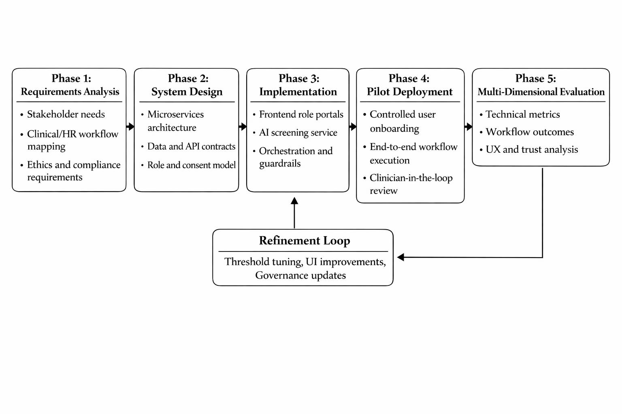
- Overall research methodology pipeline

Study Setting and Participants
The pilot involved three stakeholder groups:
- Employees (screening respondents and support recipients).
- Clinicians (review, confirmation, and labeling).
- HR managers (workplace planning and governance review).
Participants were recruited using purposive sampling from partner organizations. Inclusion and exclusion criteria were defined before data collection to ensure ethical participation and role-appropriate access. All users were assigned role-based accounts and consented to platform participation under approved governance procedures.
- Participant groups, roles, and core tasks in the CareLink workflow.
Group | Primary Role in Platform | Key Tasks | Main Outcomes Collected
Employees | Screening and disclosure | Consent, questionnaire completion, follow-up | Completion rate, time-to-support, UX ratings
Clinicians | Clinical oversight | Case review, confirm/reject screening, labeling | Confirmation agreement, review time, trust
HR Managers | Workplace support planning | Read-only governance review, accommodation planning | Decision turnaround, adoption indicators

System Architecture and Workflow Implementation
CareLink was implemented as a modular microservices architecture with a web frontend and AI-screening backend. The current MVP scope is questionnaire-first screening with clinician-in-the-loop governance. Data exchange follows structured contracts compatible with healthcare interoperability practices.
The operational workflow is:
- User authentication and role verification.
- Consent and governance validation.
- Questionnaire retrieval and completion.
- Submission to centralized orchestrator.
- Five-agent processing chain: intake and consent, feature extraction, quality and guardrails, prediction, recommendation.
- Outcome generation (low risk, possible dyslexia risk, possible dyscalculia risk, combined risk, or inconclusive).
- Escalation of high-risk or low-confidence cases to clinician review.
- Storage of responses, features, model metadata, thresholds, confidence, and audit records.
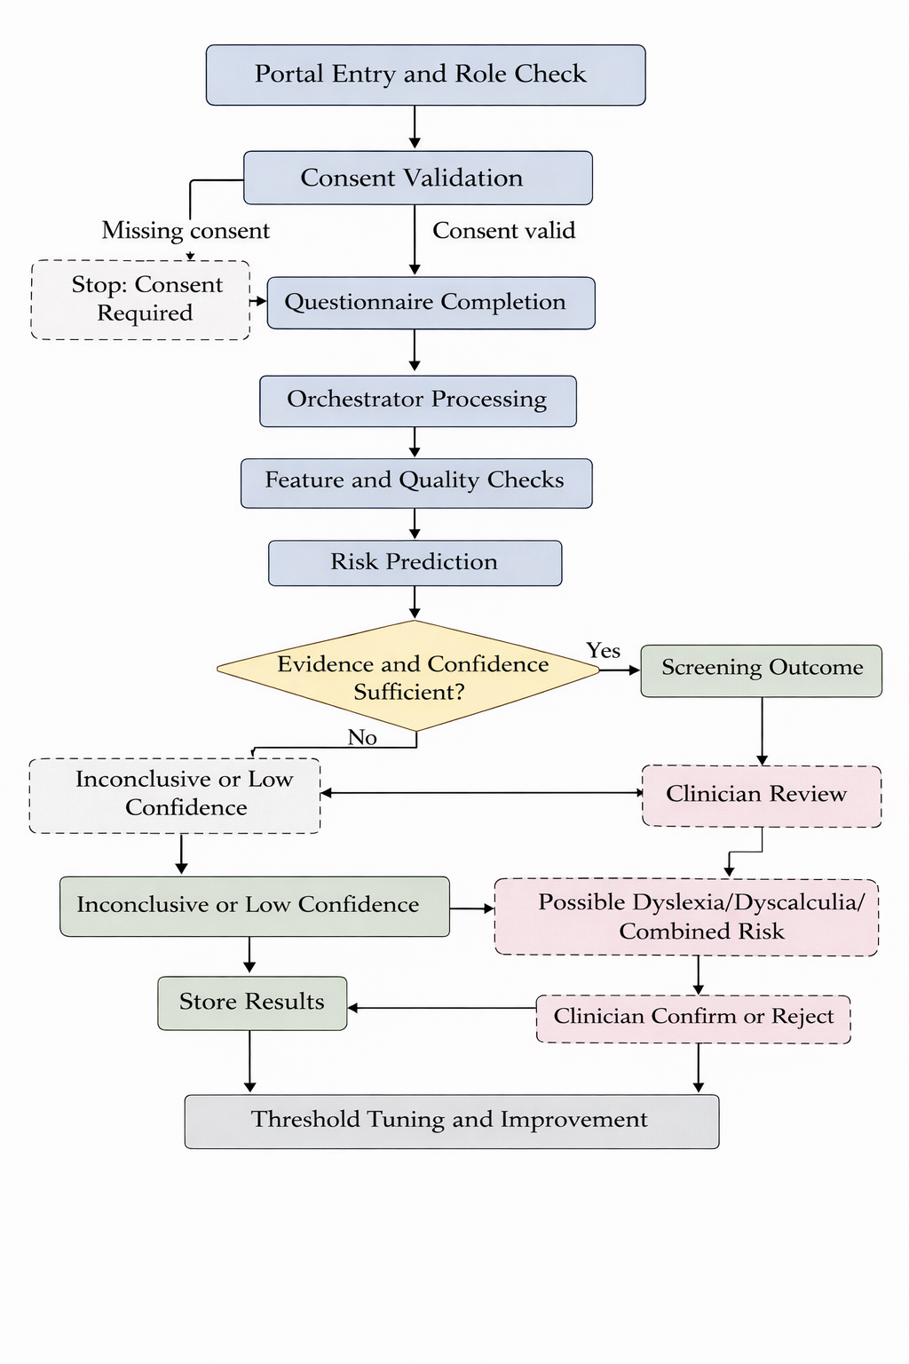

- End-to-end CareLink screening workflow and clinician escalation path.

Data Model and Feature Engineering
The MVP used structured questionnaire responses as the primary modality. Each response item was encoded with item identifier, disorder domain, construct category, modality, and normalized score boundaries. Feature engineering produced model-ready vectors including:
- Dyslexia symptom and functional-impact aggregates.
- Dyscalculia symptom and functional-impact aggregates.
- Persistence/developmental-history indicators.
- Exclusion and consistency flags.
- Submission metadata (language/version).
Quality-control checks were applied to detect missing data, contradictory patterns, and low-evidence submissions. These checks directly influenced confidence scoring and triage routing.
- Participant groups, roles, and core tasks in the CareLink workflow.
Feature Group | Example Variables | Purpose in Model / Guardrail
Dyslexia domain | Reading speed, decoding ability, spelling strain | Dyslexia risk probability
Dyscalculia domain | Number sense, arithmetic retrieval, procedural errors | Dyscalculia risk probability
Functional impact | Deadline impact, confidence reduction | Severity of workplace impact
Persistence / history | Developmental persistence indicators | Guardrail completeness checks
Exclusion / consistency | Contradiction flags, missing critical items | Confidence downgrade and escalation

AI Modeling and Decision Logic
For Phase 1, binary classification was used rather than full severity prediction. Two XGBoost classifiers were configured:
- Model A: dyslexia risk.
- Model B: dyscalculia risk.
Each inference produced a probability and a thresholded screening decision. A clinical guardrail layer then validated decision safety by checking completeness, persistence, exclusions, and contradiction patterns. Cases not meeting reliability criteria were marked inconclusive or low confidence and routed for clinician review.

Decision outputs were constrained to screening language, not diagnosis language, to preserve clinical safety and regulatory alignment.
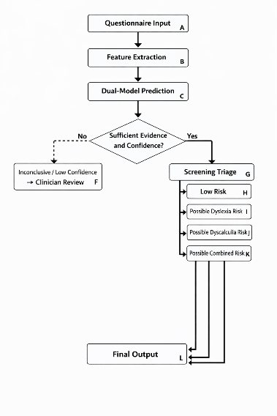

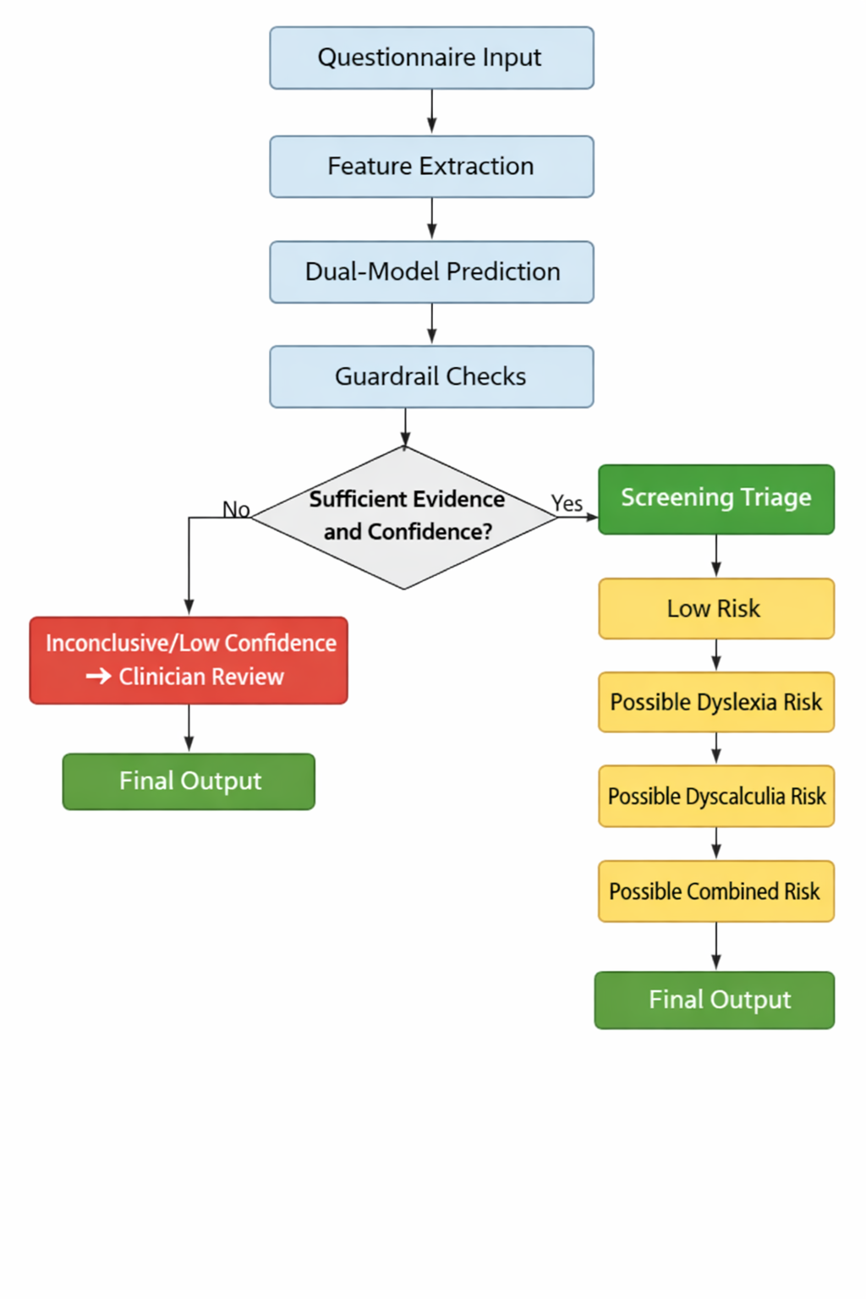
- AI decision path: feature extraction, dual-model prediction, guardrail checks, and final triage output.

Evaluation Protocol and Metrics
Evaluation combined technical, workflow, and human-factor dimensions.

- Technical performance: precision, recall, specificity, F1-score, AUC (where available), and false-negative rate for both risk models.
- Workflow performance: time-to-support, clinician review turnaround, and escalation rate.
- Human-centered performance: System Usability Scale (SUS), perceived trust, explainability satisfaction, and role-based acceptance.
A pre-post comparison design was used for workflow indicators where baseline historical process data were available. Threshold calibration used clinician-confirmed labels from pilot outcomes to optimize recall subject to minimum specificity constraints.
- Evaluation dimensions, metrics, and data sources.
Dimension | Metrics | Data Source
Model quality | Precision, recall, specificity, F1 score, AUC, false negatives | Screening service logs and labeled outcomes
Workflow efficiency | Time-to-support, review turnaround time, escalation ratio | Process timestamps and audit trail
Clinical governance | Confirm/reject agreement, low-confidence routing quality | Clinician labels and review records
User experience | SUS (System Usability Scale), trust score, perceived transparency | Post-use questionnaires and interviews

Statistical and Qualitative Analysis
Quantitative analysis was conducted using descriptive statistics and inferential tests suitable for sample size and distribution assumptions.

Recommended analysis plan:

- Descriptive summaries: mean, median, standard deviation, and confidence intervals.
- Pre-post or between-group tests: paired t-test or Wilcoxon signed-rank for non-normal data.
- Categorical outcomes: chi-square or Fisher exact test.
- Effect size reporting: Cohen d or rank-based equivalents.
Qualitative feedback from clinicians, employees, and HR managers was analyzed using thematic analysis to identify usability barriers, trust drivers, and governance concerns. Triangulation was used to integrate quantitative outcomes with qualitative findings.

Ethics, Privacy, and Governance
The methodology incorporated privacy-by-design and human oversight:

- Informed consent gating before screening.
- Role-based access control for all interfaces.
- Audit logging of scoring, thresholds, and clinician decisions.
- Restricted language to screening risk, not autonomous diagnosis.
- Clinician override and confirmation at high-risk or low-confidence points.
Data handling and governance procedures were aligned with HIPAA/GDPR principles for minimization, controlled access, and traceability.



- Governance model for consent, access control, auditability, and human-in-the-loop decision authority.

Results

Pilot Summary
The pilot included 87 participants (54 employees, 18 clinicians, 15 HR managers; TABLE I. ). From 54 questionnaires, 49 (90.7%) passed guardrails and 5 (9.3%) were inconclusive due to low-evidence or contradiction checks (TABLE II. , Fig. 3).
- PILOT SUBMISSION SUMMARY
Item | Value
Total employee submissions | 54
Passed guardrails | 49 (90.7%)
Inconclusive after QC | 5 (9.3%)
Employee participants | 54
Clinician participants | 18
HR manager participants | 15

Model Performance
Dual XGBoost screening performance is reported in **Table V**. Model A (dyslexia) outperformed Model B (dyscalculia): accuracy 0.88 vs 0.85, precision 0.86 vs 0.83, recall 0.91 vs 0.87, F1 0.88 vs 0.85, AUC 0.93 vs 0.90, and false-negative rate 0.09 vs 0.13. This indicates strong screening discrimination with recall-prioritized tuning. Outcome distribution across QC-passed cases: combined risk 12.2%, dyslexia-only 28.6%, dyscalculia-only 16.3%, low-risk 34.7%, and low-confidence escalation 8.2% (**Fig. 5**, **Fig. 6**).
- SCREENING MODEL PERFORMANCE
Section | Metric / Outcome | Dyslexia Model | Dyscalculia Model | % of QC-Passed Cases
Model performance | Accuracy | 0.88 | 0.85 | -
 | Precision | 0.86 | 0.83 | -
 | Recall | 0.91 | 0.87 | -
 | F1-score | 0.88 | 0.85 | -
 | AUC | 0.93 | 0.90 | -
 | False-negative rate | 0.09 | 0.13 | -
Triage outcome | Combined risk | - | - | 12.2
 | Dyslexia-only | - | - | 28.6
 | Dyscalculia-only | - | - | 16.3
 | Low risk | - | - | 34.7
 | Low-confidence escalation | - | - | 8.2

Workflow and Governance Outcomes
CareLink reduced mean time-to-support from 34.7 to 8.3 days (-76.1%), with significant pre-post improvement (Wilcoxon: Z = -4.12, p < 0.001, r = 0.71). Clinician review median turnaround improved from 72.0 to 18.5 hours; HR decision turnaround improved from 9.4 to 2.9 days (**Table VI**, **Fig. 7**).

Among 28 reviewed high-risk/escalated cases, clinicians confirmed 25 (89.3%) and disagreed with 3 (10.7%), with substantial agreement (Cohen's kappa = 0.74, 95% CI: 0.58-0.90).
- Workflow and governance results
Metric | Baseline | CareLink | Change
Mean time-to-support (days) | 34.7 | 8.3 | -76.1%
Clinician review turnaround (hours) | 72.0 | 18.5 | -74.3%
HR decision turnaround (days) | 9.4 | 2.9 | -69.1%
Clinician confirmation rate | - | 89.3% | -
Cohen's kappa | - | 0.74 | -

Usability and Trust
Overall usability was high (SUS 80.4, SD 8.6), with mean trust 5.5/7 (**Table VII**, **Fig. 8**). Group SUS scores were employees 81.2, clinicians 77.4, and HR managers 83.6. Qualitative feedback (n = 31) highlighted privacy confidence and workflow improvement, but requested clearer model rationale for clinicians.
- Usability and trust by stakeholder group
Group | SUS | Trust (1–7)
Employees | 81.2 | 5.6
Clinicians | 77.4 | 5.2
HR managers | 83.6 | 5.8
Overall | 80.4 | 5.5

Discussion
CareLink showed strong pilot performance in both technical screening and operational impact. Model quality (AUC 0.93/0.90; recall 0.91/0.87) supports questionnaire-first triage, while clinician agreement (kappa = 0.74) supports governance validity. The main practical gain was speed, with a 76.1% reduction in time-to-support and faster clinician/HR decision cycles.

The primary improvement area is explainability for clinician-facing review, not overall usability. Future versions should add case-level feature attribution, expand to multimodal/federated deployment, and run larger multi-site longitudinal validation.
- Table Type Styl
Table Head | Table Column Head
 | Table column subhead | Subhead | Subhead
copy | More table copyª
- Sample of a Table footnote. (Table footnote)
- Example of a figure caption. (figure caption)
Figure Labels: Use 8 point Times New Roman for Figure labels. Use words rather than symbols or abbreviations when writing Figure axis labels to avoid confusing the reader. As an example, write the quantity “Magnetization”, or “Magnetization, M”, not just “M”. If including units in the label, present them within parentheses. Do not label axes only with units. In the example, write “Magnetization (A/m)” or “Magnetization {A[m(1)]}”, not just “A/m”. Do not label axes with a ratio of quantities and units. For example, write “Temperature (K)”, not “Temperature/K”.

Acknowledgment (Heading 5)
The preferred spelling of the word “acknowledgment” in America is without an “e” after the “g”. Avoid the stilted expression “one of us (R. B. G.) thanks ...”. Instead, try “R. B. G. thanks...”. Put sponsor acknowledgments in the unnumbered footnote on the first page.

References
The template will number citations consecutively within brackets [1]. The sentence punctuation follows the bracket [2]. Refer simply to the reference number, as in [3]—do not use “Ref. [3]” or “reference [3]” except at the beginning of a sentence: “Reference [3] was the first ...”
Number footnotes separately in superscripts. Place the actual footnote at the bottom of the column in which it was cited. Do not put footnotes in the abstract or reference list. Use letters for table footnotes.
Unless there are six authors or more give all authors’ names; do not use “et al.”. Papers that have not been published, even if they have been submitted for publication, should be cited as “unpublished” [4]. Papers that have been accepted for publication should be cited as “in press” [5]. Capitalize only the first word in a paper title, except for proper nouns and element symbols.
For papers published in translation journals, please give the English citation first, followed by the original foreign-language citation [6].

- G. Eason, B. Noble, and I. N. Sneddon, “On certain integrals of Lipschitz-Hankel type involving products of Bessel functions,” Phil. Trans. Roy. Soc. London, vol. A247, pp. 529–551, April 1955. (references)
- J. Clerk Maxwell, A Treatise on Electricity and Magnetism, 3rd ed., vol. 2. Oxford: Clarendon, 1892, pp.68–73.
- I. S. Jacobs and C. P. Bean, “Fine particles, thin films and exchange anisotropy,” in Magnetism, vol. III, G. T. Rado and H. Suhl, Eds. New York: Academic, 1963, pp. 271–350.
- K. Elissa, “Title of paper if known,” unpublished.
- R. Nicole, “Title of paper with only first word capitalized,” J. Name Stand. Abbrev., in press.
- Y. Yorozu, M. Hirano, K. Oka, and Y. Tagawa, “Electron spectroscopy studies on magneto-optical media and plastic substrate interface,” IEEE Transl. J. Magn. Japan, vol. 2, pp. 740–741, August 1987 [Digests 9th Annual Conf. Magnetics Japan, p. 301, 1982].
- M. Young, The Technical Writer’s Handbook. Mill Valley, CA: University Science, 1989.
- K. Eves and J. Valasek, “Adaptive control for singularly perturbed systems examples,” Code Ocean, Aug. 2023. [Online]. Available: https://codeocean.com/capsule/4989235/tree
- D. P. Kingma and M. Welling, “Auto-encoding variational Bayes,” 2013, arXiv:1312.6114. [Online]. Available: https://arxiv.org/abs/1312.6114
- S. Liu, “Wi-Fi Energy Detection Testbed (12MTC),” 2023, gitHub repository. [Online]. Available: https://github.com/liustone99/Wi-Fi-Energy-Detection-Testbed-12MTC
- “Treatment episode data set: discharges (TEDS-D): concatenated, 2006 to 2009.” U.S. Department of Health and Human Services, Substance Abuse and Mental Health Services Administration, Office of Applied Studies, August, 2013, DOI:10.3886/ICPSR30122.v2

IEEE conference templates contain guidance text for composing and formatting conference papers. Please ensure that all template text is removed from your conference paper prior to submission to the conference. Failure to remove template text from your paper may result in your paper not being published.

